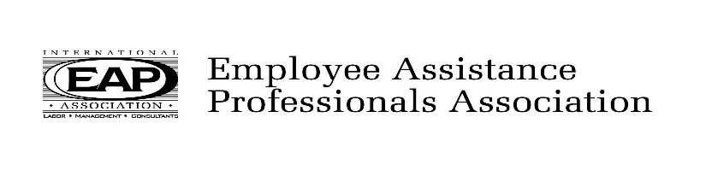
2020 Monthly Calendar of Events

January 17, 2020
Interventions in First Psychotic Breaks and
Maintaining Chronic Psychotic Symptoms
Chloe Dean-Highland Springs

February 21, 2020
When Grief Gets Complicated
Julia Ellifritt, LISW-S
Cornerstone of Hope

March 20, 2020
Question, Persuade, Refer (QPR)
Prevention Training
Carmen Grandarilla, LSW
Cuyahoga County ADAMHS Board

April 17, 2020
Creating a Psychologically Healthy Workforce
As part of a Wellness Strategy
Kim Hauge, PHR, SHRM-CP, Kent State University
Luci Styles Payne, CEAP, IMPACT Solutions

May 15, 2020
Gregg Delap, CEAP
Chief Executive Officer EAPA
Topic TBD

June 19, 2020
Abstinence Based Recovery: Past, Present, Future
Gary Seech-Glenbeigh

July 17, 2020
Personality Disorders: Faces of the Unhealed
Joshua Hill

August 21, 2020
The Transgender client
Antone Feo, Ph.D

September 18, 2020 (3 hours, 9:30am-12:30pm)
Legal, Ethical and Professional Responsibilities
Related to Clinical Supervision
Joellen K. Woodring, LPCC-S

October 16, 2020
Diversity Committee

November 20, 2020
Creating a culture of safety in the workplace
Tim Dimoff, CPP, President of SACS
Natasha Cramer, LPCC-S, LICDC, SAP, CEAP, Meridian HealthCare

December 11, 2020(2nd Friday of the month)
Wellness Best Practices
EAPA Program Planning Committee

Monthly programs are held the third Friday of each month at
CWA/4340 Union Hall, 1400 E. Schaaf Rd., Brooklyn Hts., 44131
9:00 am - 9:15 am Continental breakfast and networking
9:15 am - 11:30 am Presentation and discussion
2.0 Professional hours are available for CEAPs, LICDCs, Counselors and Social Workers
**unless listed otherwise
$20 for Non-members
All paid admissions include program, CEUs and continental breakfast
http://www.ohioeapa.com
