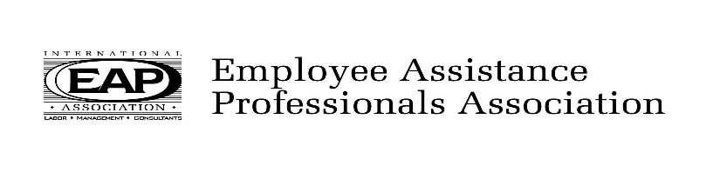
2021 Monthly Calendar of Events

January 15, 2021 - VIRTUAL*  Recovery Issues in the COVID-19 World  Ray Isackila, LPCC - ARS | July 16, 2021 – Format to be determined  New Trends in Substance Use Disorder Treatment  Dr. Theodore Parran, Medical Director for Glenbeigh
February 19, 2021 - VIRTUAL*  Generational Diversity  Holly Brown, Ph.D - IMPACT Solutions | August 20, 2021 – Format to be determined  Diversity - TBD
March 19, 2021 - VIRTUAL*  What is the WorkPlace Outcomes Suite?  How can it help my EAP?  Sharon Saia MSW, LISW-S  Director, Ohio State Employee Assistance Program | September 17, 2021 – Format to be determined  Caregiving
April 16, 2021 - VIRTUAL*  2020 EAP CIR: A Mulit-Sytemic Resiliency Approach.  Robert Inveldt, LCSW, CEAP  Anna Tyrrell, M.Ed., LSW, LPC | October 15, 2021 – Format to be determined  (3 hours, 9:30am-12:30pm)  Ethics  Amy Freadling, Ph.D, LPCC-S, CEAP  Director-Cleveland Clinic EAP
May 21, 2021 - VIRTUAL*  Human Trafficking  Sister Anne Victory | November 19, 2021 – Format to be determined  Non-Substance Addictions
June 18, 2021 – VIRTUAL*  Mindfulness & COVID-19  Daron Larson, Mindfulness Coach,  Attentional Fitness Training | December 17, 2021 – Format to be determined  EAPA Year in Review  Greg DeLapp, CEO EAPA

*During COVID-19 and restricted in person meetings, registrants will be supplied with a meeting link to attend virtually. CEUs will be available as usual. When in-person meetings are safe and permitted, monthly programs are held the third Friday of each month at CWA/4340 Union Hall, 1400 E. Schaaf Rd., Brooklyn Hts., 44131
9:00 am - 9:15 am Continental breakfast and networking
9:15 am - 11:30 am Presentation and discussion
2.0 Professional hours are available for CEAPs, LICDCs, Counselors and Social Workers unless listed otherwise

$20 for Non-members
All paid admissions include program & CEUs
http://www.ohioeapa.com

