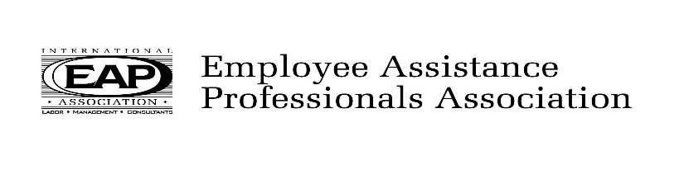
2023 Calendar of Events
All Events are Virtual

January 20, 2023  Program Title: Harm Reduction Treatment & Trauma Informed Care  Presenter: Sherie Fredrich, PsyD. Clinical Psychologist  PersueCare  2-hour program | July 21, 2023  Program Title: Positive Psychology  Presenter: Ruth Bowdish, MSPsy, LICDC, CEAP, SAP  On Demand Occupational Medicine  2-hour program
March 17, 2023  Program Title: Neurodiversity and the Importance of Honoring Identities  Presenter: Jinger Kinner, MFT, LPCC  2-hour Program  May 19, 2023  Program Title: Ethics  Presenter: Johni Fiber, LPCC-S  - 3-hour Program | September 15, 2023  Program Title: The History of Addiction & Recovery  Presenter: Gary Seech, CEO  Glenbeigh  2-hour program  November 10, 2023  Program title: The 3 Ds: Dementia, Delirium & Depression  Presenters: Lisa Weitzman, MSSA, LISW-S, ASW-G,  C-ASWCM & Kelsey Loushin, LICDC-CS, CDP 2-hour program
Eventbrite registration is used for all attendees. A Zoom link will be provided to attend virtually. CEUs will be available within 2 weeks following the program. All participants MUST BE VISIBLE to receive ceu credit.

8:45 am - 9:00 am Introductions and announcement
9:00 am - 11:15 am Presentation (15-minute break included)

2.0 Professional hours are available for CEAPs, LICDCs, and Ohio Counselors and Social Workers. The May 19th program fulfills the 3 hour Ethics requirement for Ohio Counselors and Social Workers.

$20 for Non-members
All paid admissions include program & CEUs
http://www.ohioeapa.com

